3/22/2022

Chirag Gaur

Deloitte

Installation Guide

on

**Linux**

**Table of Contents**

|  |  |  |
| --- | --- | --- |
| **S. No** | **Topic** | **Page No.** |
| 1. | Setting up a Virtual Machine | 2 |
| 2. | Downloading Ubuntu | 2 |
| 3. | Setting up Ubuntu on VM | 3-7 |

# Setting up a Virtual Machine

* Download VMware workstation pro from the below URL.

<https://www.vmware.com/in/products/workstation-pro/workstation-pro-evaluation.html>

* Scroll down and Select the download option for Windows

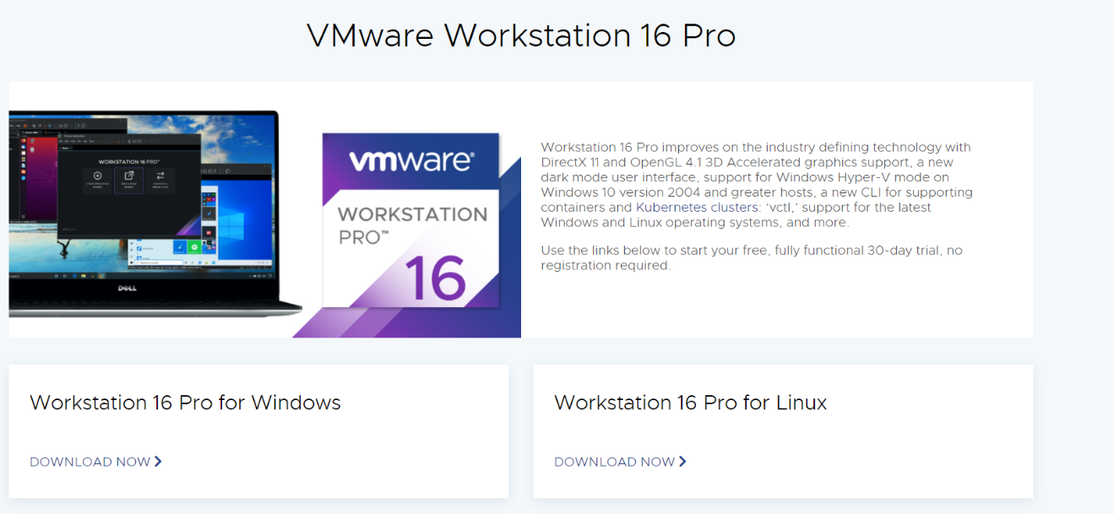

1. **Downloading Ubuntu**

* Download Ubuntu from the below URL:
* <https://ubuntu.com/download/desktop>

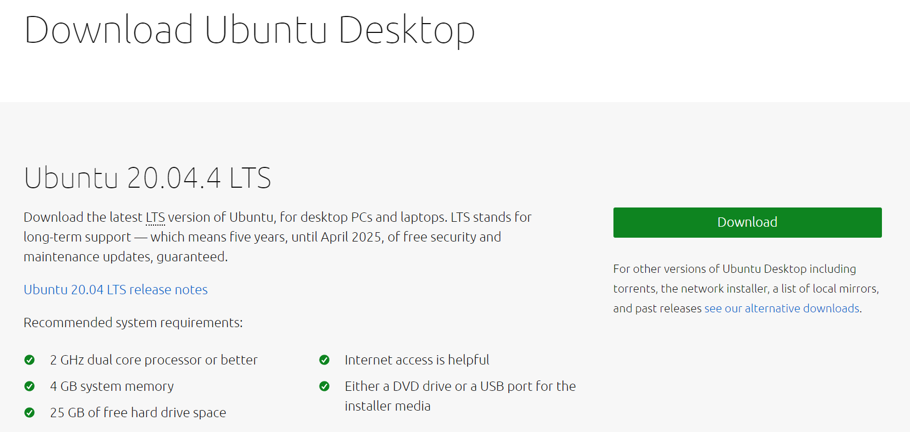

1. **Setting up Ubuntu on VM**

* Select **Create a New Virtual Machine** options in the home tab of VMware Workstation Pro.

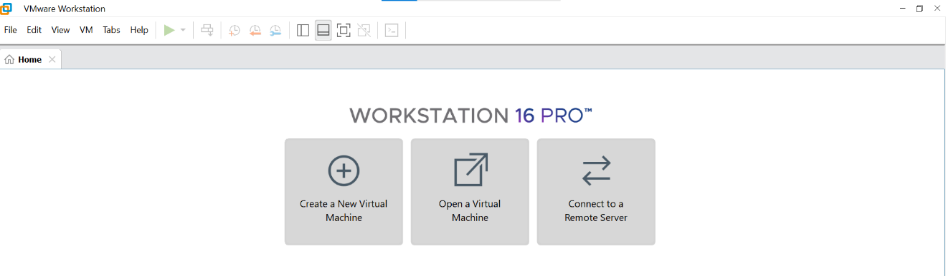

* Choose **Typical (recommended)** options available in **New Virtual Machine Wizard** and Select **Next.**

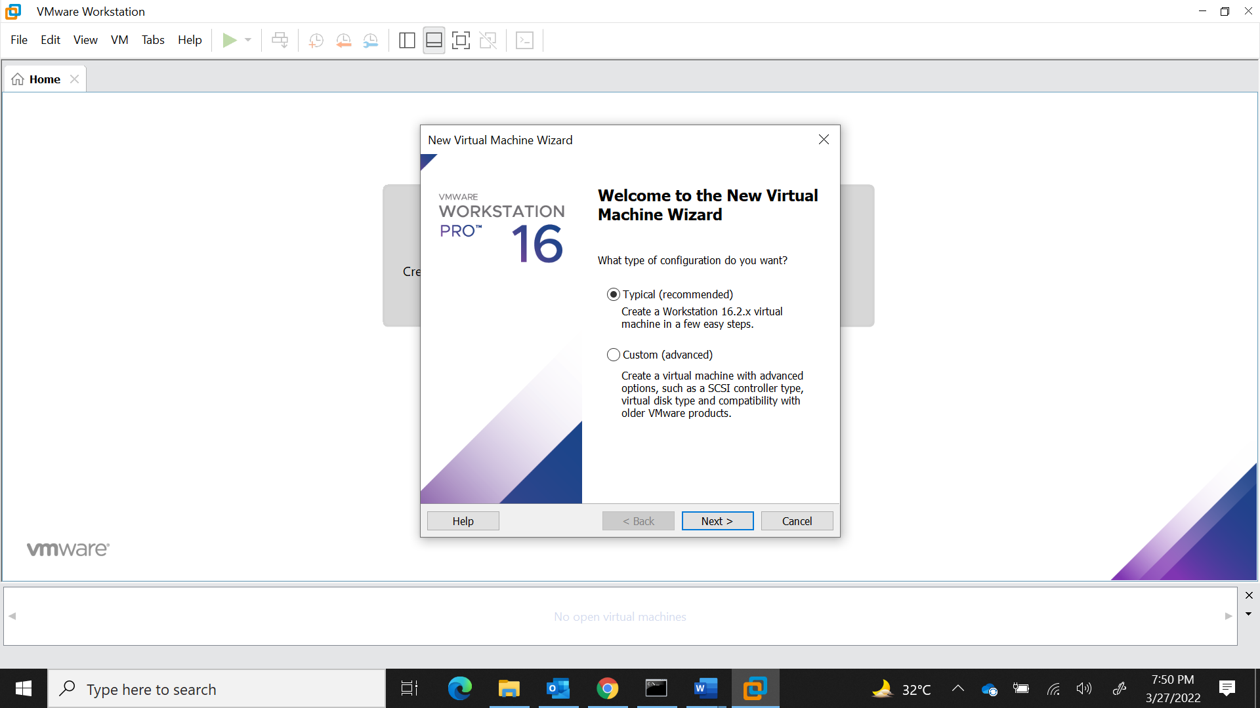

* Select the Ubuntu file path in **Installer disc image file (iso)** options and Select **Next**.

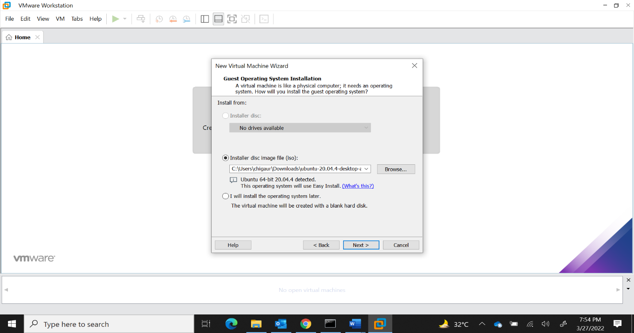

* Provide **Full Name, User name, Password** as shown below and Select **Next**

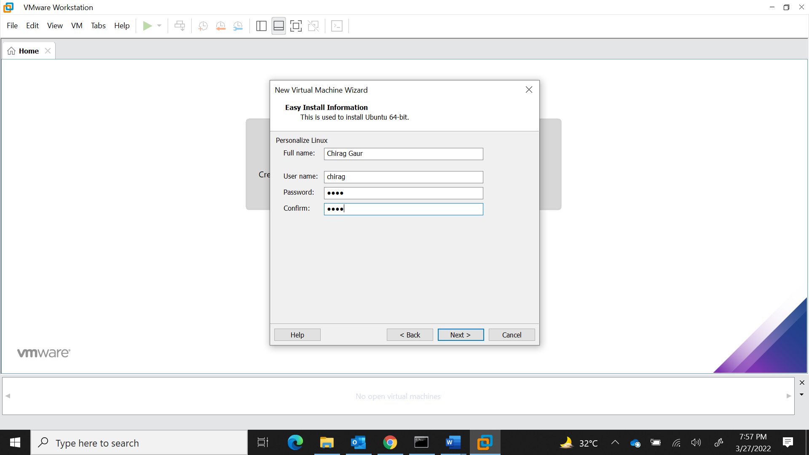

* Provide the Virtual Machine name and Select **Next**

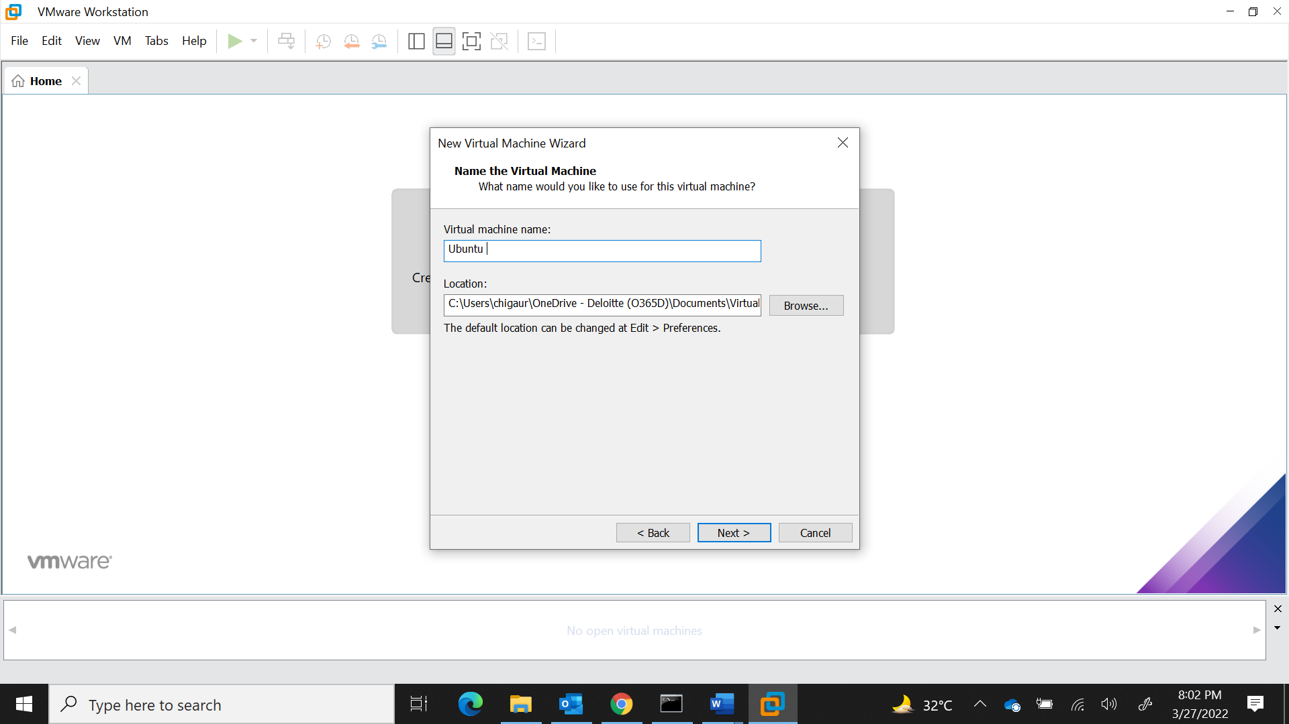

* Under the **Specify Disk Capacity Wizard**, we can choose **Maximum disk size**. Leave the disk size to default and Select **Next**.

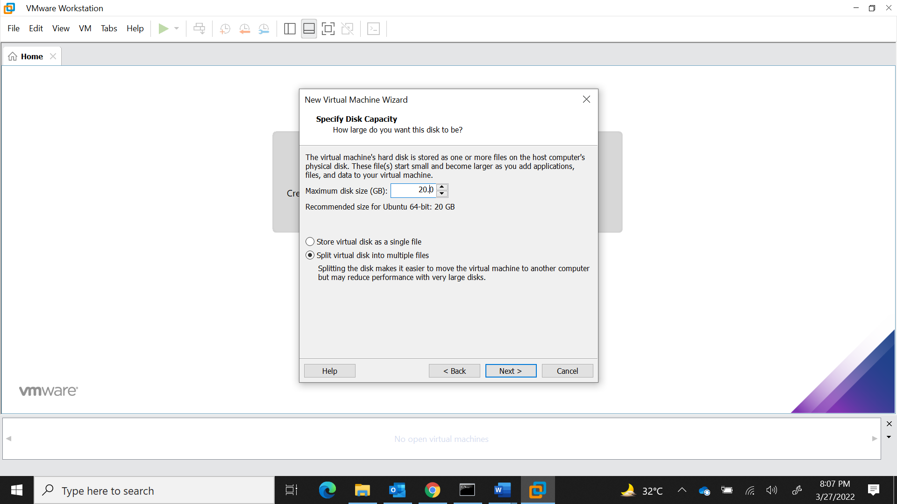

* The below image shows the details of the VM created and Select **Finish** to finish the installation process.

